Assignment 13.4
G.Abhishek
2303A52469
Batch-43

Task 1: Refactoring Data Transformation Logic
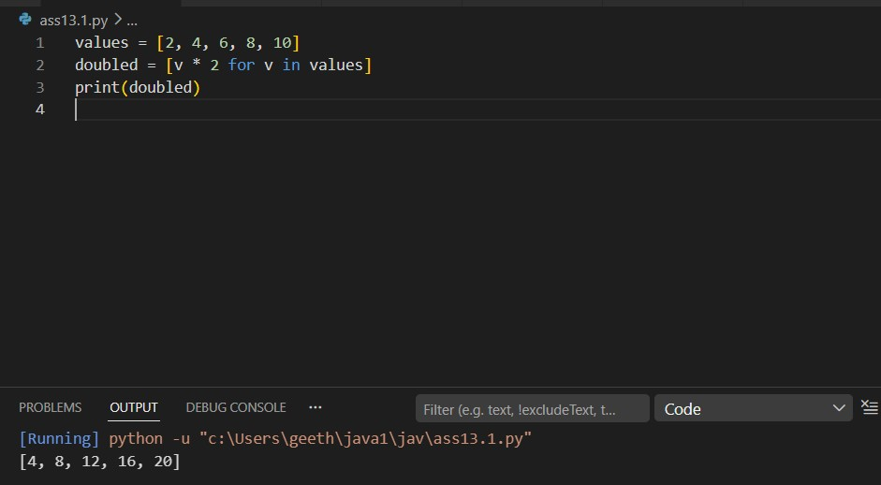

Task 2: Improving Text Processing Code Readability
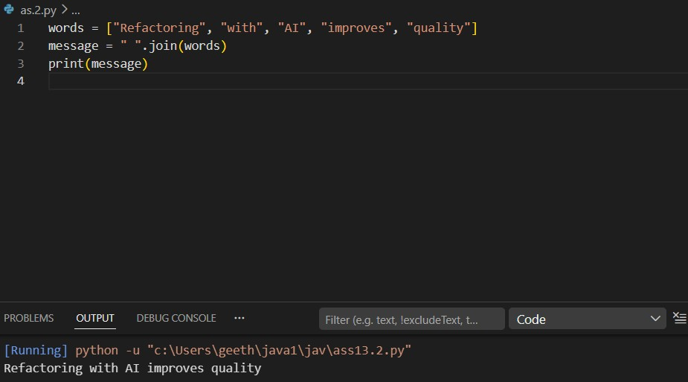
Task 3: Safer Access to Configuration Data
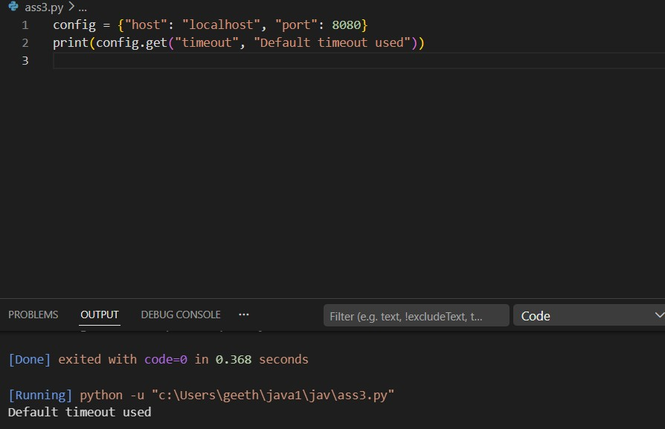

Task 4: Refactoring Conditional Logic for Scalability
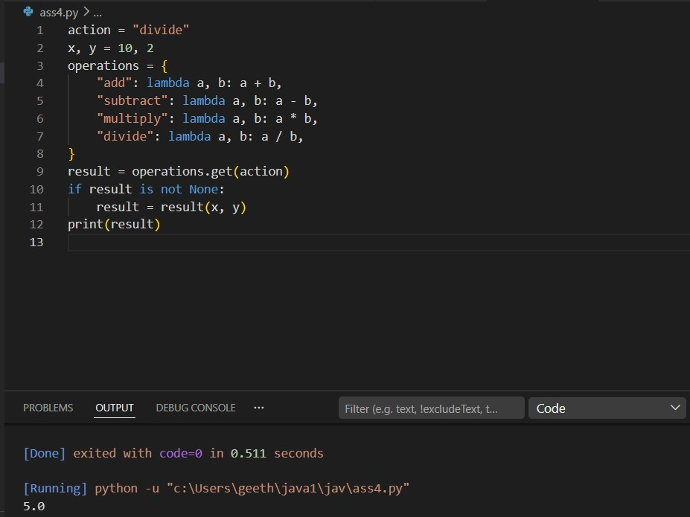

Task 5: Simplifying Search Logic in Collections
